|  |  |
| --- | --- |
| Date | 20 September 2022 |
| Team ID | PNT2022TMID15139 |
| Project Name | Smart Farmer - IoT Enabled Smart Farming Application |
| Maximum Marks | 4 Marks |

**LITERATURE SURVEY AND PROBLEM STATEMENTS**

Abstract – For the increasing population growth and for the demanding food supply needs, the normal provisioning systems with existing methodologies seems to be unworthy and requires and advanced facilitations with optimal usage of water resources (irrigational resources). Hence a smart monitoring system of the farmland conditions and other subsidies may help us for a better productivity.

This could be made possible by sensing the physical parameters such as temperature, moisture and other soil parameters periodically and transferring over a user interface application could helps us to analyse the better situations of crop conditions.

Introduction - Agriculture is the art and science of cultivating the soil, growing crops and raising livestock. It includes the preparation of plant and animal products for people to use and their distribution to markets.

Agriculture provides most of the world’s food and fabrics. Cotton, wool, and leather are all agricultural products. Agriculture also provides wood for construction and paper products.

Environmental changes are likely to affect agricultural production since decades. The interactions between environmental change, agricultural yields and crop

quality, and the critical pathways to future diets and health outcomes are largely undefined. There are currently no quantitative models to test the impact of multiple environmental changes on nutrition and health outcomes.

Hence there arises a need for the monitoring of environmental conditions and other timely factors for better crop conditions.

In this paper, the system uses few sensors which gives the amount of moisture in the soil, the humidity and temperature of the region, and a rain detecting sensor which and can be used in deciding whether the crop is suitable for growing. All these sensors along with Node MCU are connected to the internet and a smartphone.

Proposed Solution- Smart Farming Methodology and monitoring systems

With the assuming of internet of things in different areas like Industry, Homes and even Cities, huge potential is seen to make everything Intelligent and Smart. The proposal system of even the Agricultural sector is also adopting IoT technology these days and this in turn has led to the development of “AGRICULTURAL Internet of Things (IoT)”.

Internet of things based on the regarded as IoT gadget focusing on Live Monitoring of Environmental data in terms of Temperature, Moisture and other types depending on the sensors integrated with it. The provides the concept of “Plug & Sense” in which farmers can directly implement smart farming by as such putting the System on the field and getting the based on different mechanism like Smart Phones, Tablets etc. and the data developed via sensors can be easily shared and viewed by agriculture consultants anywhere remotely via Cloud Computing technology integration. The smart farming system also enables analysis of various sorts of data via Big Data Analytics from time to time.

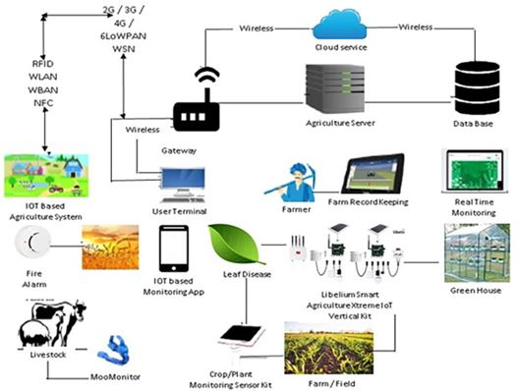

Implementation of Smart Farming System

Components employed in real time kinetic systems

ARDUINO UNO

It is a microcontroller board based on the ATmega328(datasheet). It has 14 digital input/output pins (of which 6 can be used as PWM outputs),6 analog inputs, a 16 MHz crystal oscillator, a USB connection, a power jack, an ICSP header, and a reset button.

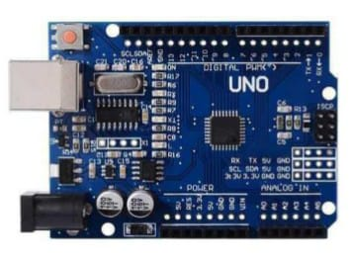

PHYSICAL ENVIRONMENTAL MEASURANDS-

HUMIDITY AND TEMPERATURE SENSOR(DHT11)

Humidity and temperature sensor (DHT11) consists of a thermistor, humidity sensing component and an IC. Thermistor calculates the temperature of its surrounding medium from its capability of varying its resistance due to temperature. A moisture holding substrate is placed between two electrodes in humidity sensing component. The variation in humidity produces a variation in resistance between electrodes. The variation in resistance is measured and processed by the IC which gives the humidity value to the NodeMCU. This sensor operates at a voltage range of 3.3V to 5V. The range of temperature is 0 - 50°C, range of humidity is 20 - 90% RH.

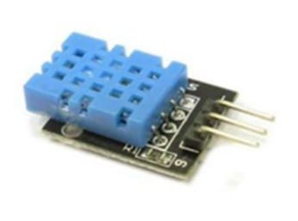

SOIL MOISTURE SENSOR

The Soil Moisture Sensor calculates the average of dielectric permittivity along the length of the sensor. Here, dielectric permittivity is function of water. The temperature range for the working of this sensor is 10 - 30°C and voltage applied is 5V.

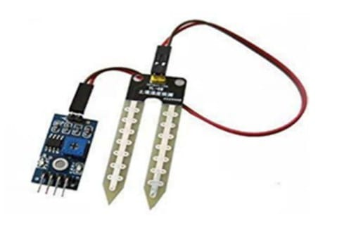

RAINDROP SENSOR

In raindrop sensor, as raindrops fall on the nickel lines the drop connects these lines in parallel which reduces the resistance and hence the voltage drop across the lines is also reduced. This happens because water is a good conductor of electricity. When the voltage drop is less than a certain value it indicates that it’s raining. The module has a rain board, a control board, power indicator LED, and an adjustable sensitivity through a potentiometer. Its operating voltage is 5V. The range of resistance is from 100KOhm to 2MOhm.

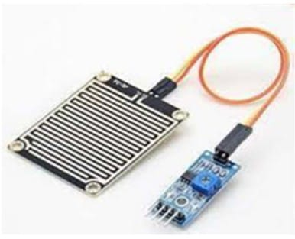

NODE MCU

NodeMCU is an open source IoT platform which includes firmware that runs on ESP8266 Wi-Fi module. Programming is done in Arduino IDE using C/C++ language or Lua script. NodeMCU has 16 GPIO pins which can be used to control other peripheral devices like sensors, LEDs, switches etc. These pins can also be used as PWM pins. It has two UART interfaces and uses XTOS operating system [7]. It can store 4M Bytes of data. The operating voltage of NodeMCU is 5V. It uses L106 32-bit processor, and the processor's speed is 80-160MHz.

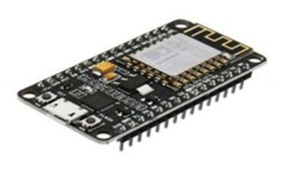

Further this integrated system requires a wireless connectivity through internet between the agricultural sensor nodes and the cloud storage, hence provided for a systemic data transfer.

SIMULATION WORKSPACE

But for simulative workspace it requires different entities in software platform for checking the components vulnerableness in the working environmental conditions.

FRONT-END DEVELOPMENT

For a simulative workspace, initially it requires a sensor nodes inter-connecting platform such as an integrated development platform for various end nodes such as tinkercad and various others,

Tinkercad is a free-of-charge, online 3D modeling program that runs in a web browser. Since it became available in 2011 it has become a popular platform for creating models for 3D printing as well as an entry-level introduction to constructive solid geometry in schools.

Further it requires a connectivity over the internet for the transfer of data over the cloud data space storage and then those data gets transferred to the user end application interface.

BACK-END PROCESSES

At the back end, it requires a cloud- services at various levels.

In our project we have used out IBM Watson is a fully managed, cloud hosted service that makes it simple to derive value from Internet of Things (IoT) devices.

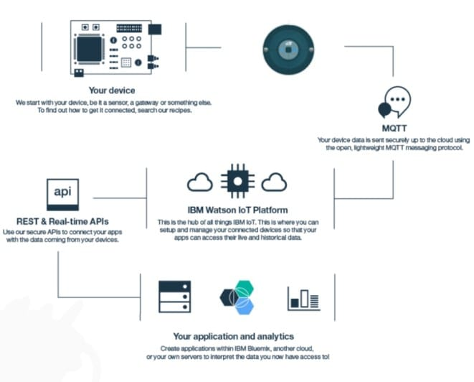

Then it goes on with the node red interconnective platform for functional design with the device-oriented user interface application.

OVERALL TECHNICAL ARCHIETECTURE-

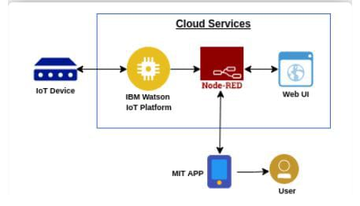

CONCLUSION

In this paper, IoT technology is used to sense and analyze the temperature, humidity level, soil moisture level and the rain condition. All these values are sent to the smart phone using internet Wi-Fi connectivity from cloud iot device. Due to the usage of this system, adequate water is pumped and rain is also utilized efficiently. This system is very much helpful to farmers as they need to regularly pump water and check the status of each crop. From anywhere in the world, farmers can know the values of humidity, temperature and soil moisture and various other physical parameters.

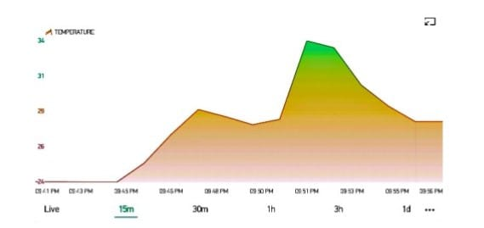

Temperature at different time intervals

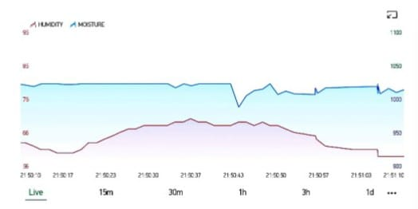

Humidity and moisture at different time intervals.

The internet of things based smart farming System being proposed via this report will assist farmers in increasing the agriculture yield and take efficient care of food production as the System will always provide helping hand to farmers for getting accurate live feed of environmental temperature and soil moisture with more than 99% accurate results.